- Get the connection URI (Uniform Resource Identifier) for the MongoDB shell.
Database – Cluster0 – Connect – Access your data through tools – MongoDB for VS code –
3. Connect to your MongoDB deployment – copy the connection string

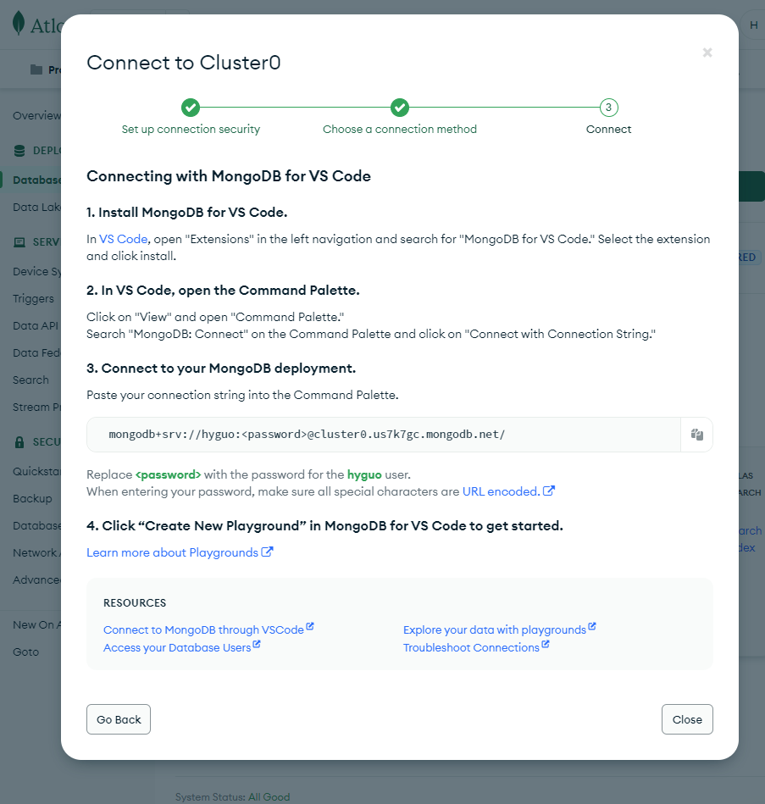
- Using the URI, connect to your cluster from your laptop.
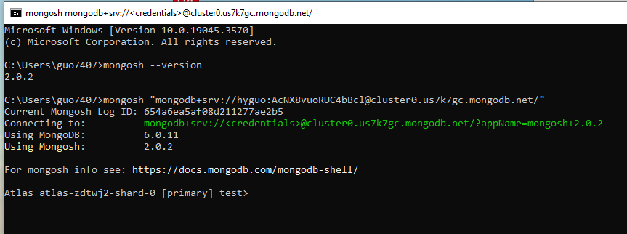

- Get the connection URI (Uniform Resource Identifier) for the MongoDB Compass. Using the URI, connect to your cluster from your computer.

Database – Cluster0 – Connect – Access your data through tools – Compass –
I have MongoDB Compass Installed – 2. Copy the connection string, then open MongoDB Compass - copy the connection string
- Load File with mongoimport
You can use mongoimport to import data from a JSON or a CSV file into MongoDB Atlas cluster.

https://www.mongodb.com/docs/atlas/import/mongoimport/

https://www.mongodb.com/docs/atlas/compass-connection/

